Step 1: Github cloning

Step 1:

git clone https://github.com/udacity/DevOps_Microservices.git

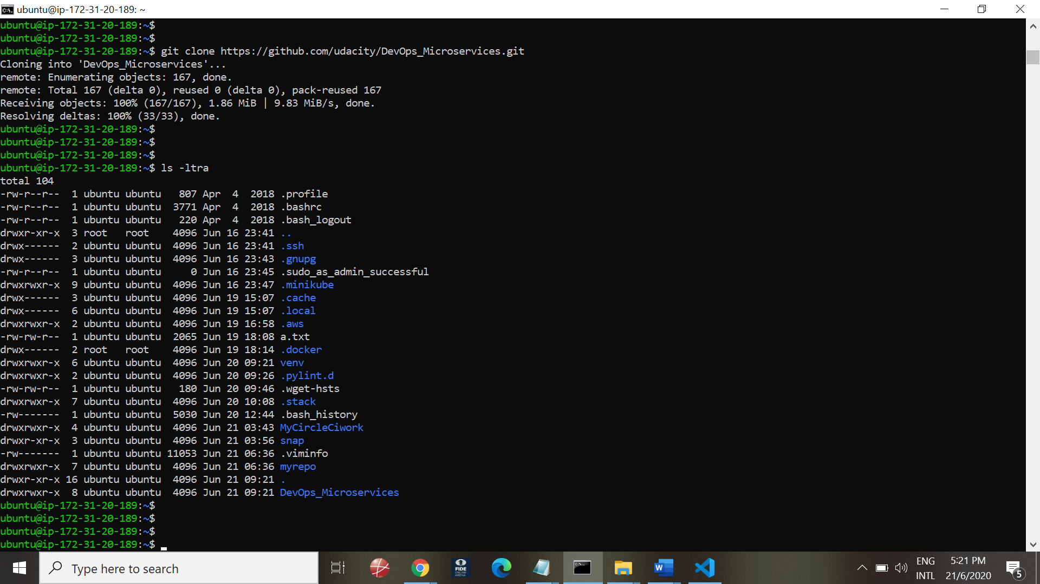

Created a GitHub Repository

<https://github.com/Anandatreya/Microservices_Kubernetes.git>

Step 2: Circleci setup & config.yml

git clone <https://github.com/Anandatreya/Microservices_Kubernetes>.git

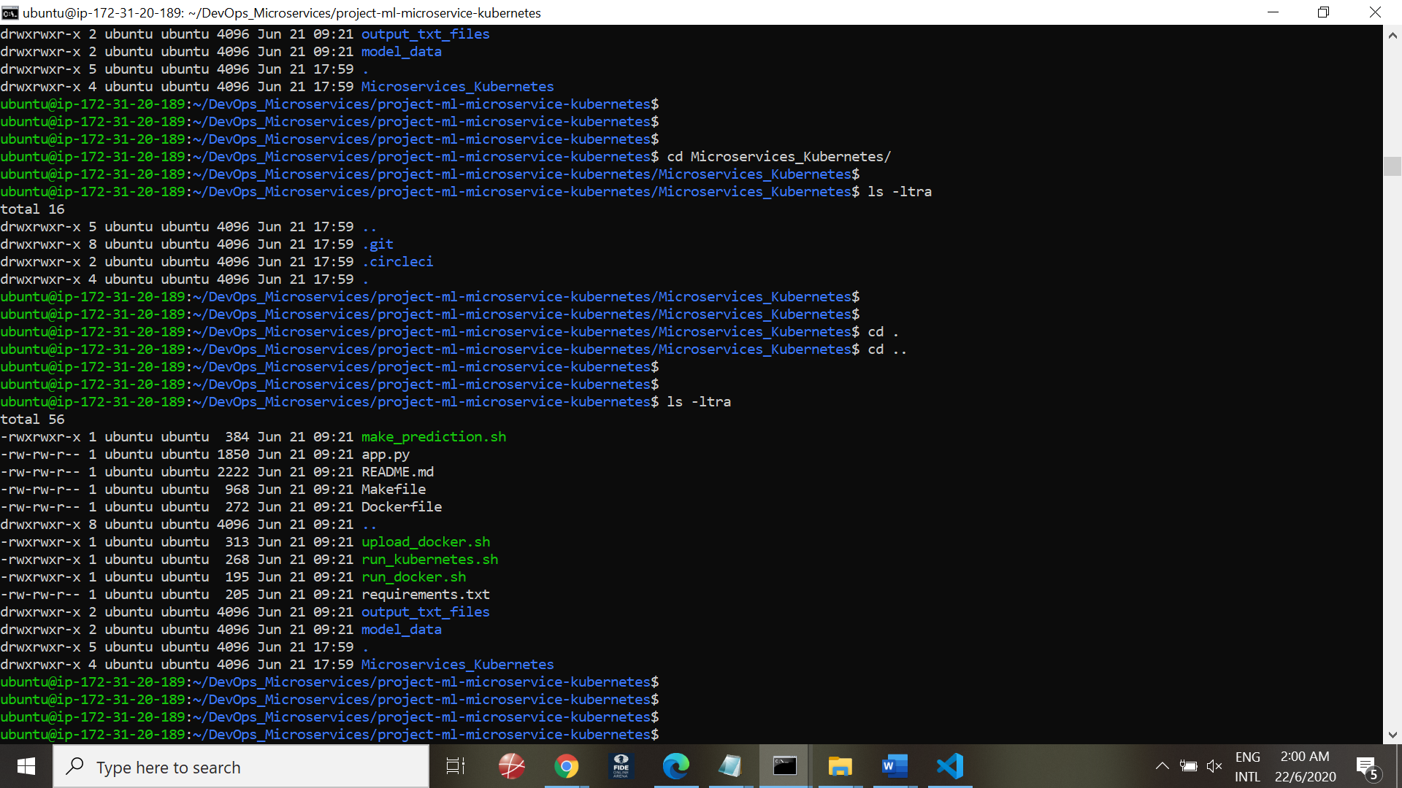

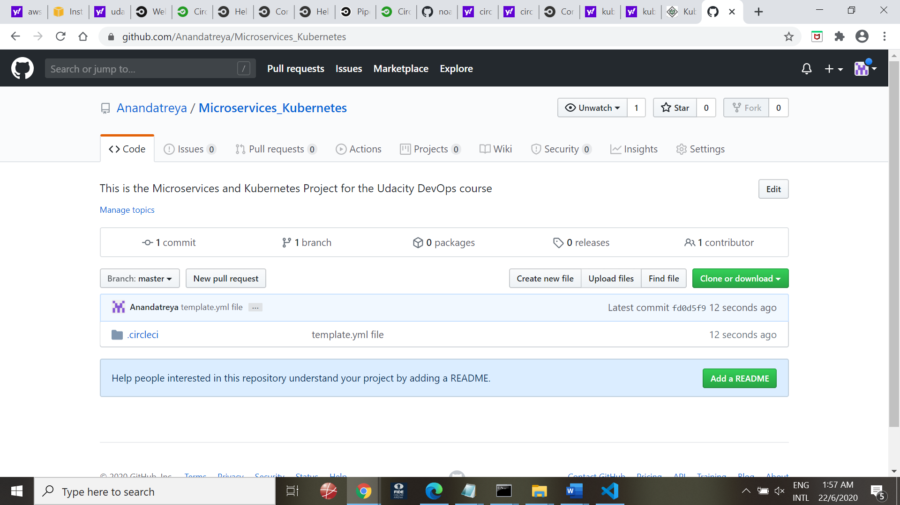

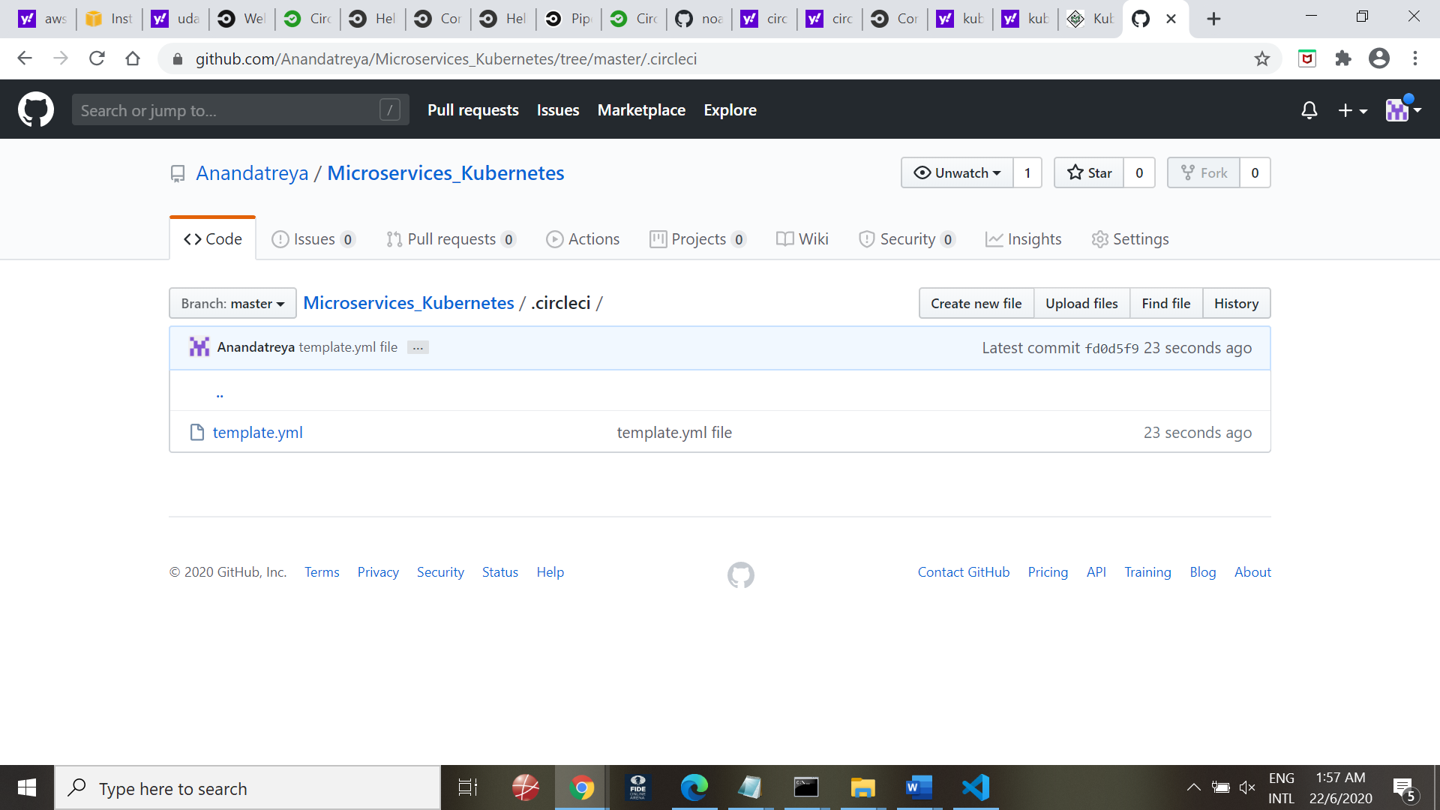

Step 2:

Clone the repository into the server

Create (and activate) a new environment, named .devops with Python 3. If prompted to proceed with the install (Proceed [y]/n) type y.

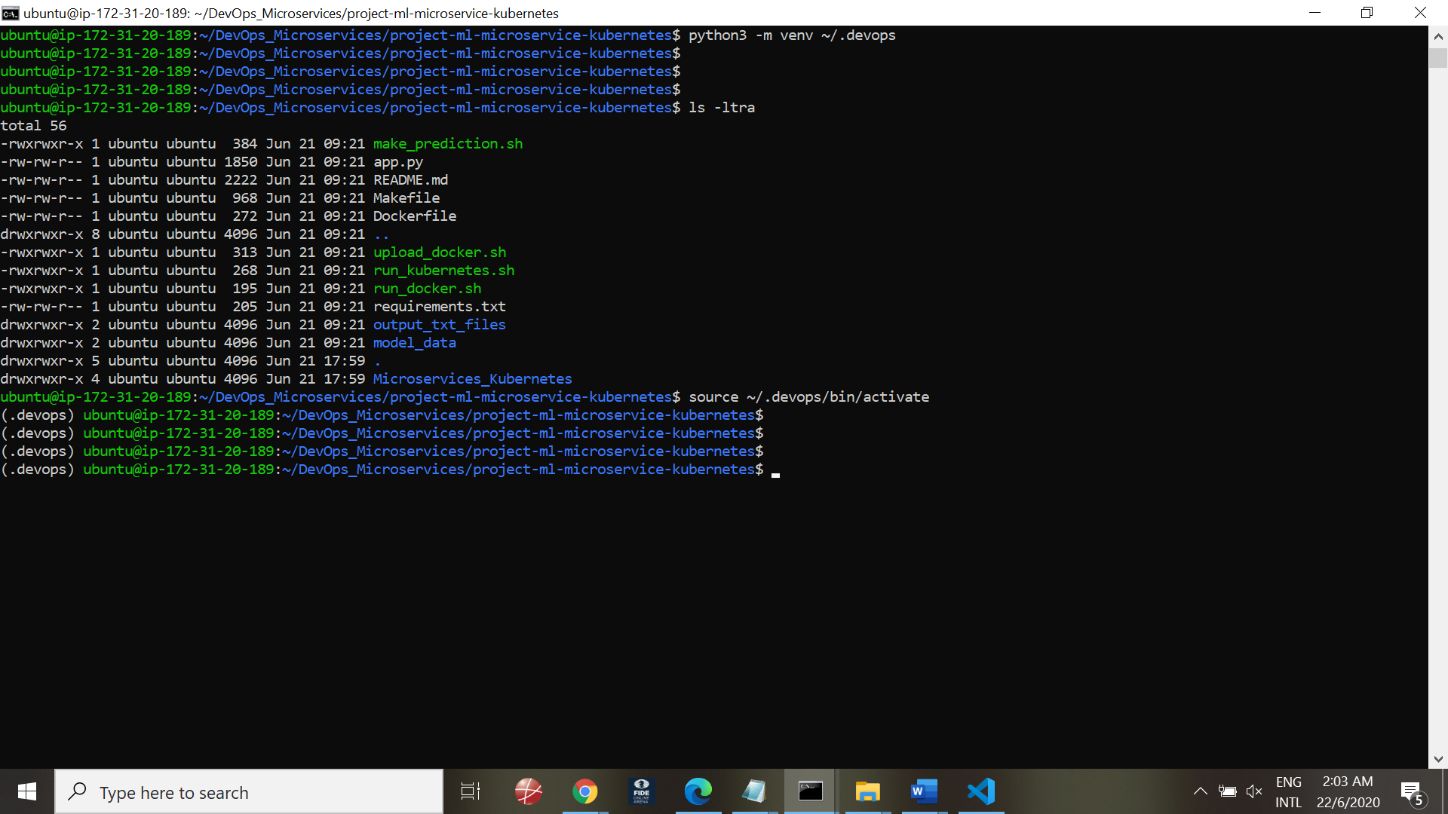

Installing dependencies via project Makefile. Many of the project dependencies are listed in the file requirements.txt; these can be installed using pip commands in the provided Makefile. While in your project directory, type the following command to install these dependencies.

Make install

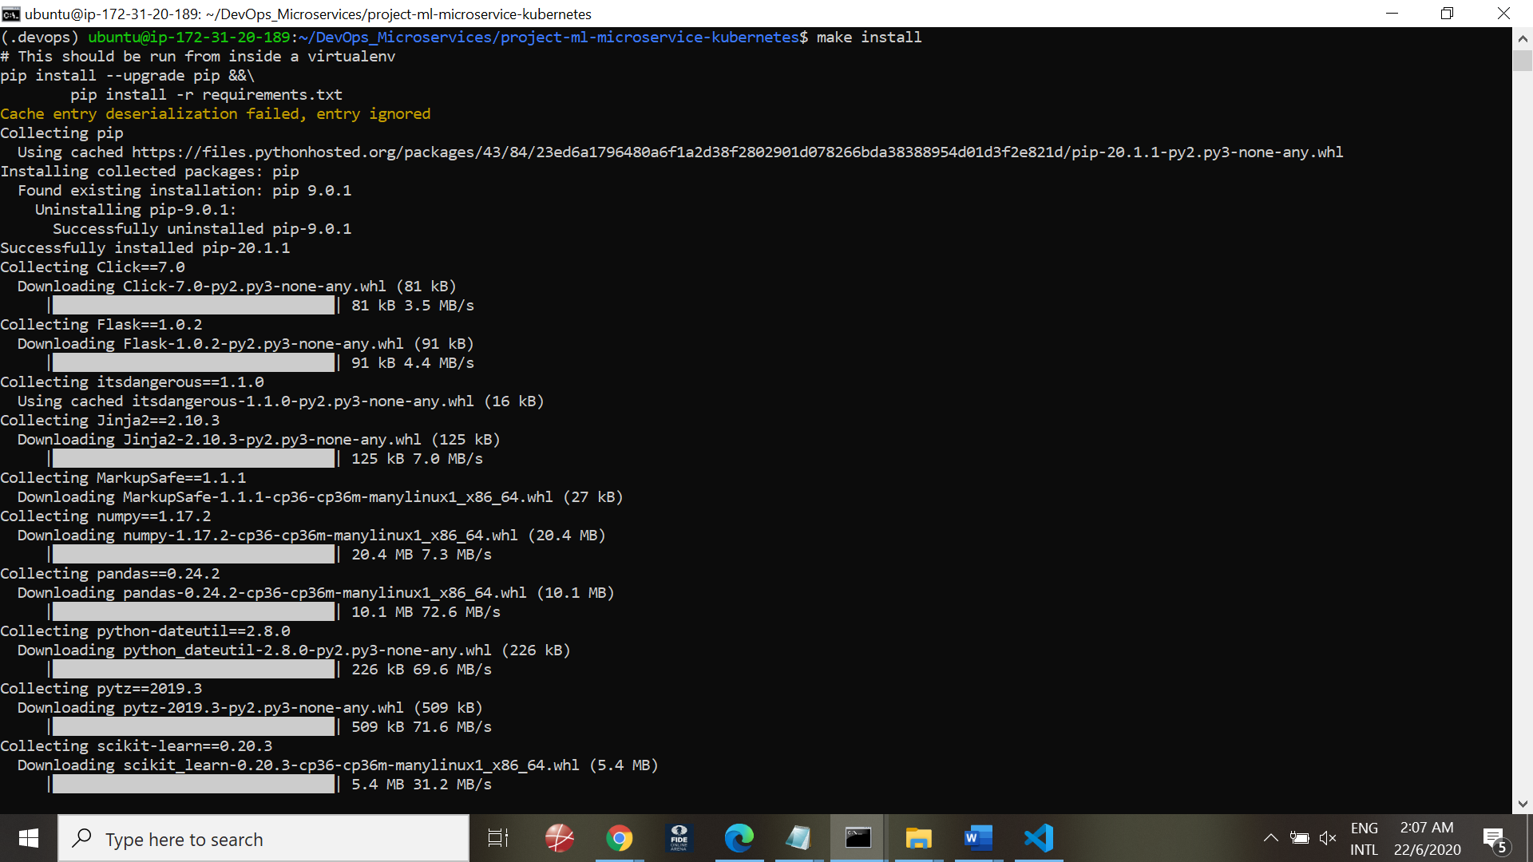

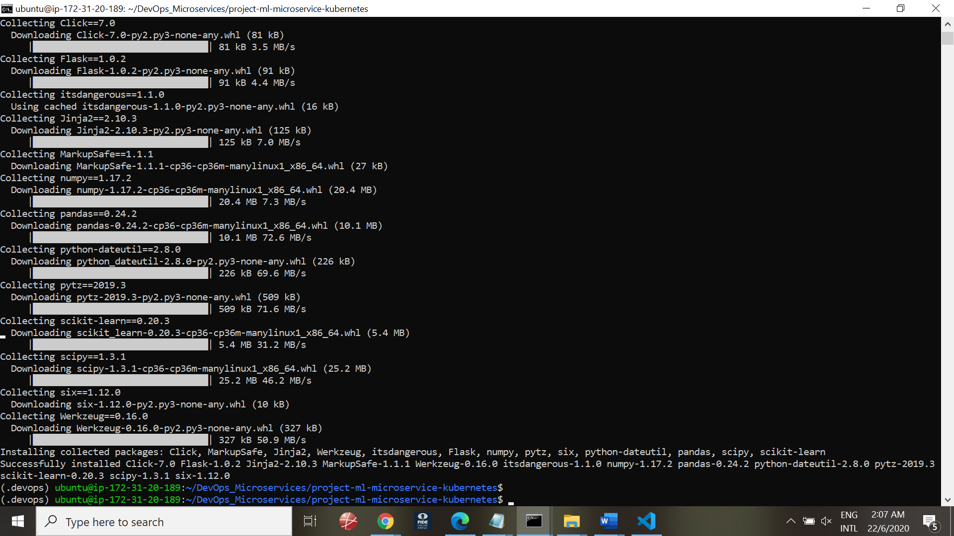

**Other Libraries**

While you still have your .devops environment activated, you will still need to install:

* Docker
* Hadolint
* Kubernetes (Minikube)

Docker version

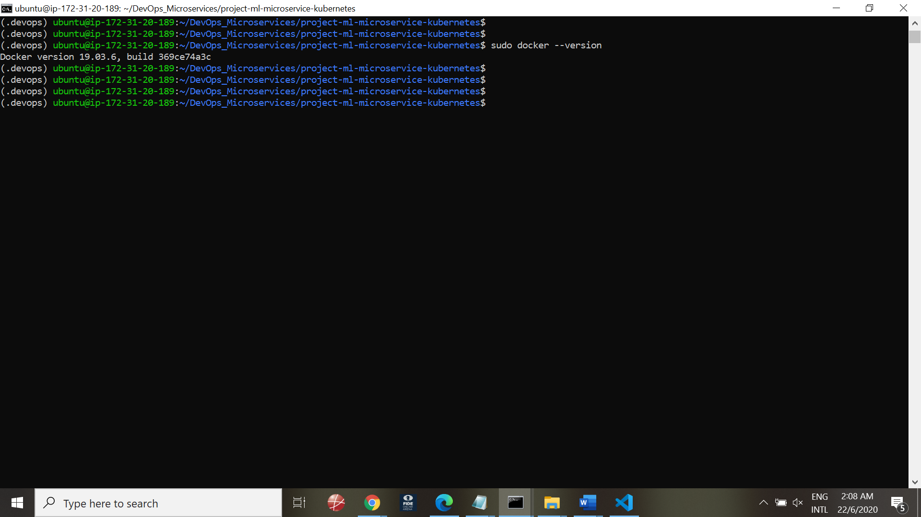

## Run Lint Checks

Hadolint Dockerfile

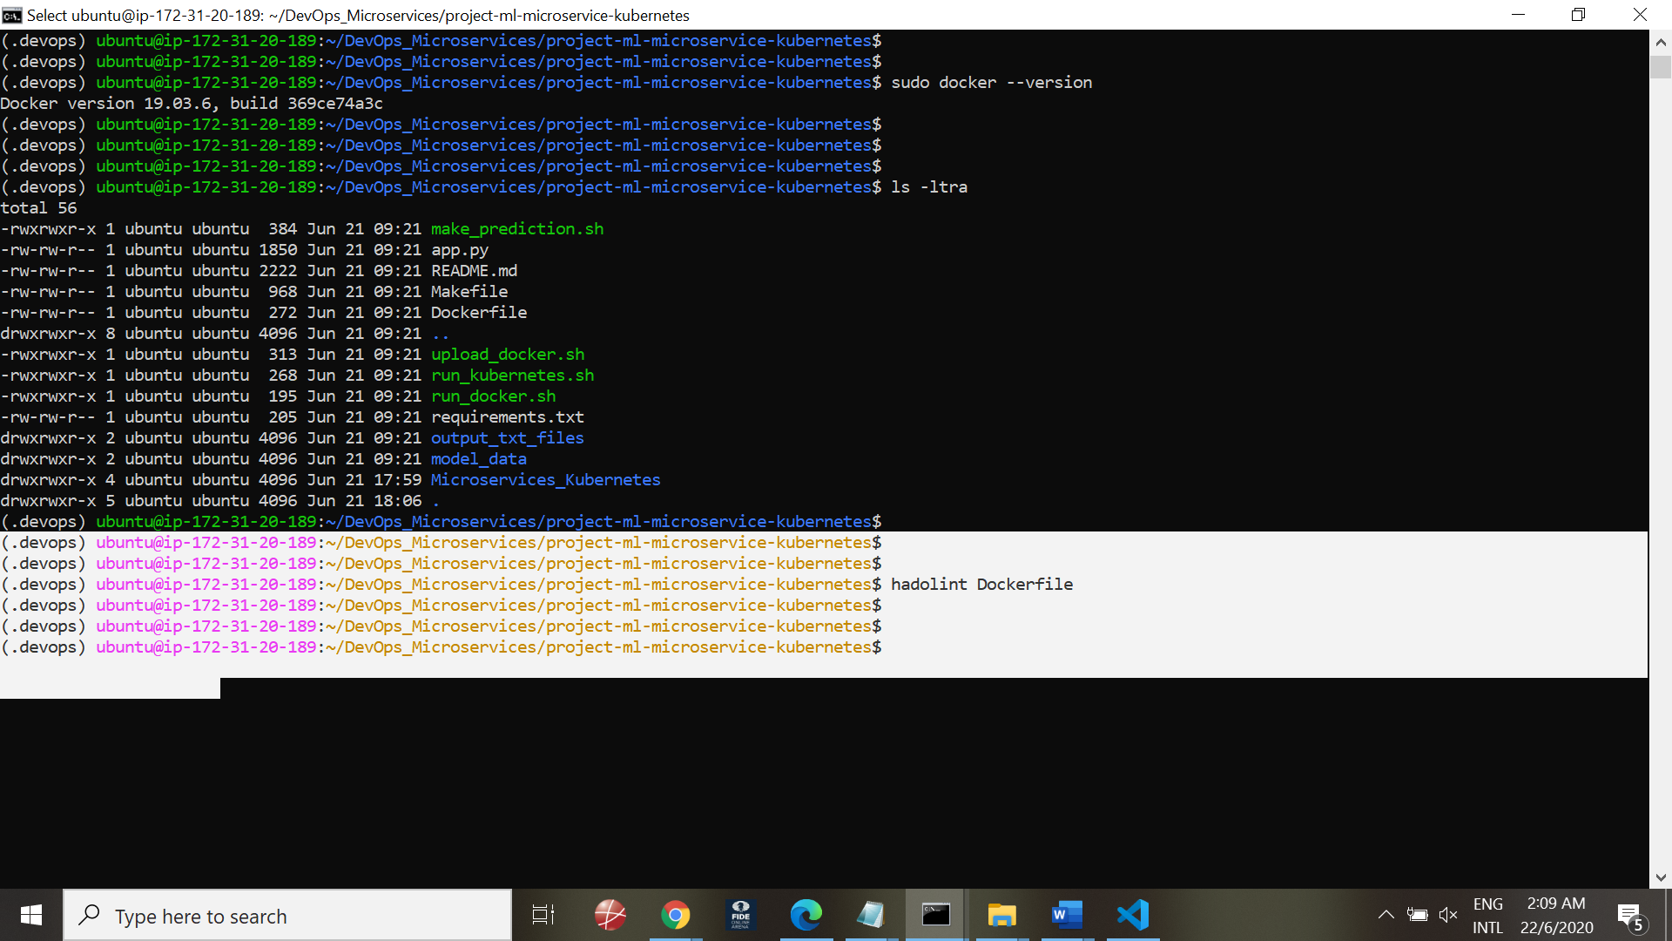

Make lint

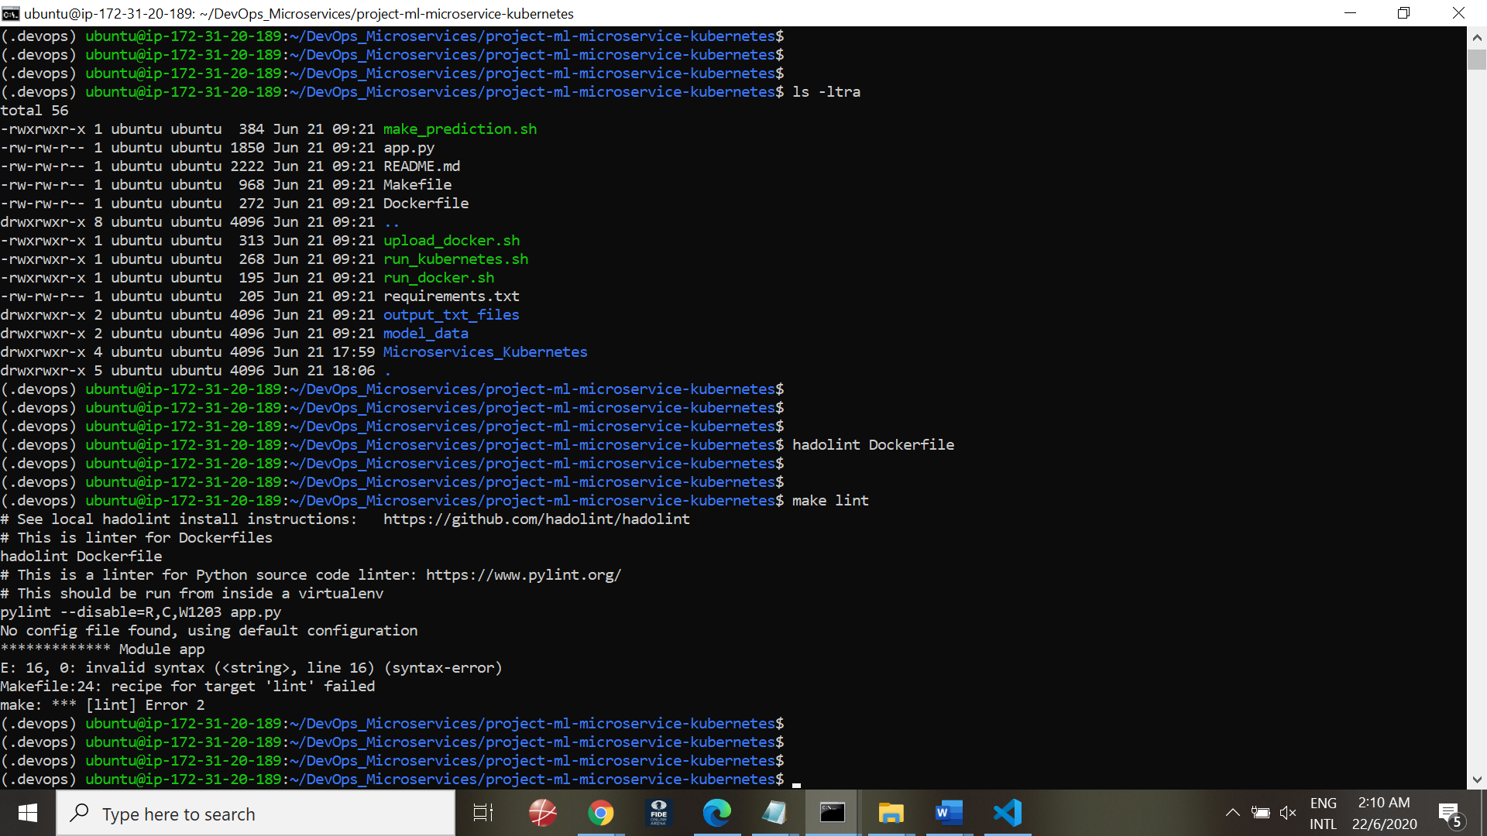

Linting errors with code syntax in Python code (Lines 23 useage of F)

#2 Sklearn packages not found

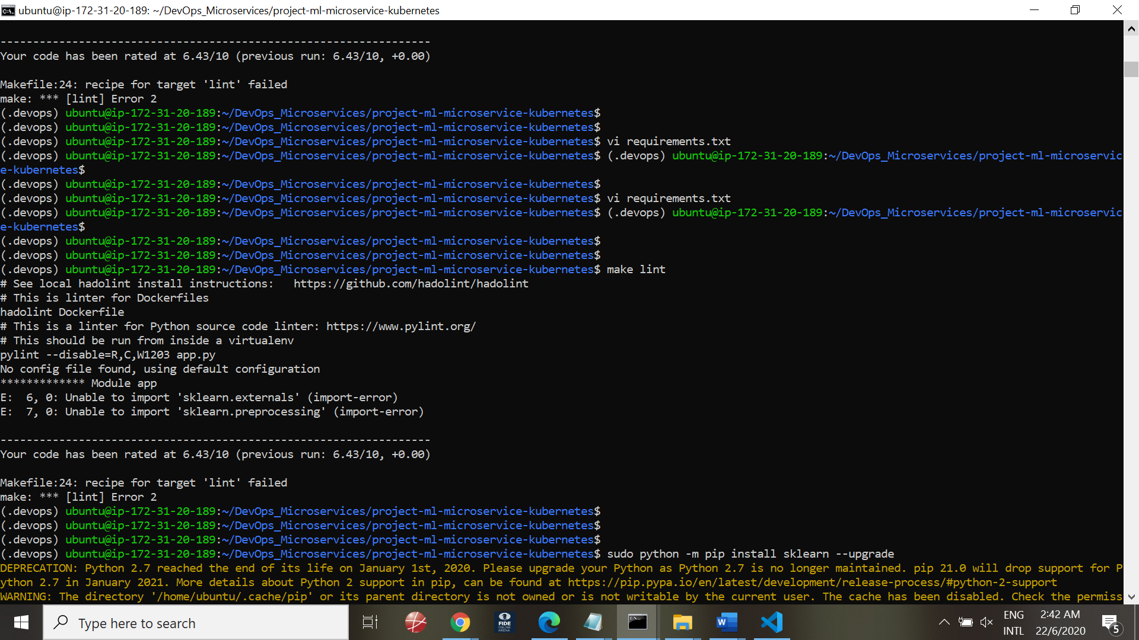

Solution:

Installed sklearn and joblib packages

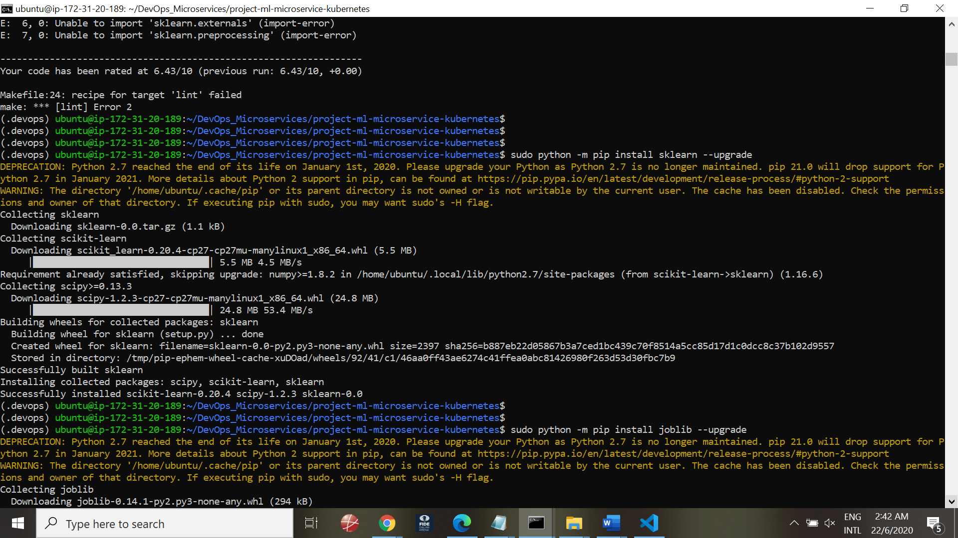

Make lint successful after correcting these coding errors

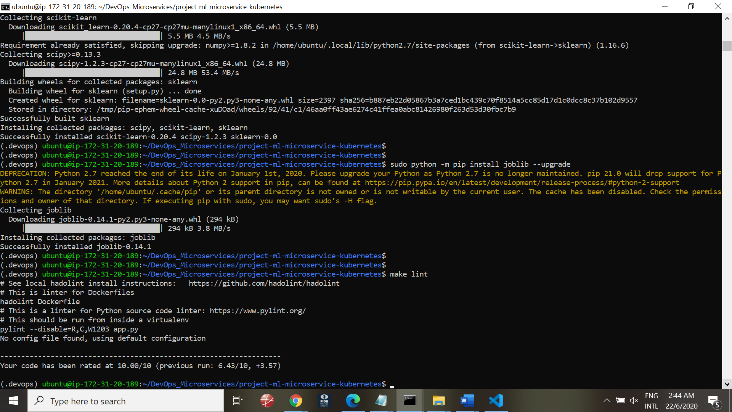

## Install Minikube

